Experiment no. 07

nano pract7.c

CODE:
#include <stdio.h>
#include <semaphore.h>
sem_t mutex,full,empty;
int x=0;
void producer(){
sem_wait(&empty);
sem_wait(&mutex);
x++;
printf("Producer produces item %d\n",x);
sem_post(&mutex);
sem_post(&full);
}
void consumer(){
sem_wait(&full);
sem_wait(&mutex);
printf("Consumer consumes item %d\n",x);
x--;
sem_post(&mutex);
sem_post(&empty);
}
int main(){
sem_init(&mutex,0,1);
sem_init(&empty,0,1);
sem_init(&full,0,0);
producer();
consumer();
return 0;
}

OUTPUT:
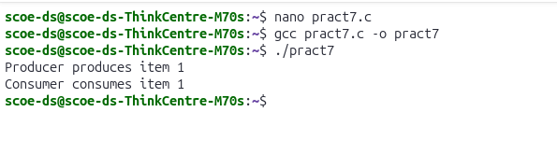

AIM
Write a C program to implement the Producer–Consumer problem using
Semaphore.

RESOURCES REQUIRED
Ubuntu Operating System
Terminal
Text Editor (nano)
GCC Compiler

THEORY
The Producer–Consumer problem is a classic synchronization problem in Operating
Systems. It describes two processes, the producer and the consumer, which share a
common fixed-size buffer.
The producer produces data and places it into the buffer.
The consumer consumes data from the buffer.
If the buffer is full, the producer must wait.
If the buffer is empty, the consumer must wait.
To solve this problem, semaphores are used for synchronization.
Semaphores Used
mutex – ensures mutual exclusion so that only one process accesses the buffer
at a time.
empty – counts the number of empty buffer slots.
full – counts the number of filled buffer slots.
This mechanism prevents race conditions, buffer overflow, and buffer underflow.

CONCLUSION
Thus, the program to implement the Producer–Consumer problem using Semaphore
was successfully executed. The semaphore mechanism ensured proper
synchronization between producer and consumer processes and prevented race
conditions.

